Distributed File Systems (DFS)
# Source: Chatgpt (GPT-5-Mini) at [1/16/2026]
A Distributed File System is a type of distributed system that allows files to be stored across multiple physical locations (servers or nodes) but provides users with the illusion of a single, unified file system.
It enables transparent access, sharing, and management of files across a network.

Definition
# Source: Chatgpt (GPT-5-Mini) at [1/16/2026]
A Distributed File System:
- Stores files on multiple servers
- Allows clients to access files as if they are local
- Provides fault tolerance, replication, and concurrent access

Architecture Diagram
# Source: Chatgpt (GPT-5-Mini) at [1/16/2026]
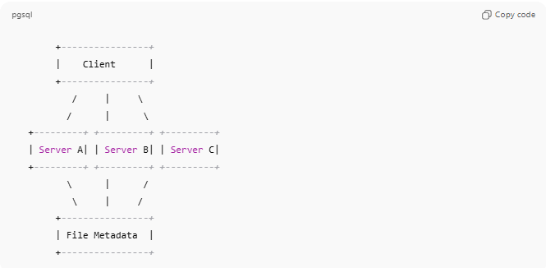
+----------------+
| Client |
+----------------+
/ | \
/ | \
+---------+ +---------+ +---------+
| Server A| | Server B| | Server C|
+---------+ +---------+ +---------+
\ | /
\ | /
+----------------+
| File Metadata |
+----------------+
- Clients access files through the DFS interface
- Servers store the actual data
- Metadata server (optional) manages file locations and directory structure

Key Characteristics
# Source: Chatgpt (GPT-5-Mini) at [1/16/2026]
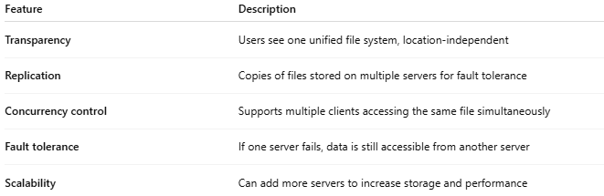
Feature | Description
Transparency | Users see one unified file system, location-independent
Replication | Copies of files stored on multiple servers for fault tolerance
Concurrency control | Supports multiple clients accessing the same file simultaneously
Fault tolerance | If one server fails, data is still accessible from another server
Scalability | Can add more servers to increase storage and performance

How It Works
# Source: Chatgpt (GPT-5-Mini) at [1/16/2026]
- A client requests access to a file
- DFS determines the server(s) storing the file
- File is retrieved (or updated) from the server
- Metadata is updated if needed, ensuring consistency across replicas

Advantages
# Source: Chatgpt (GPT-5-Mini) at [1/16/2026]
- Transparent access: Files appear local to users
- High availability: Replication prevents data loss
- Scalable storage: Add more servers as storage needs grow
- Collaboration: Multiple users can share and access files

Disadvantages
# Source: Chatgpt (GPT-5-Mini) at [1/16/2026]
- Complex design and implementation
- Network dependency: slow or unreliable networks affect performance
- Synchronization and consistency management can be challenging

Examples
# Source: Chatgpt (GPT-5-Mini) at [1/16/2026]
- Google File System (GFS)
- Hadoop Distributed File System (HDFS)
- Andrew File System (AFS)
- Ceph

Simple Analogy
# Source: Chatgpt (GPT-5-Mini) at [1/16/2026]
- Distributed File System: A library with multiple branches
  - Books (files) are stored in different branches (servers)
  - Patrons (clients) can borrow any book as if it’s in one library
  - If one branch is closed, books are available from other branches

